Tilleggsmateriell til gudstjenesten

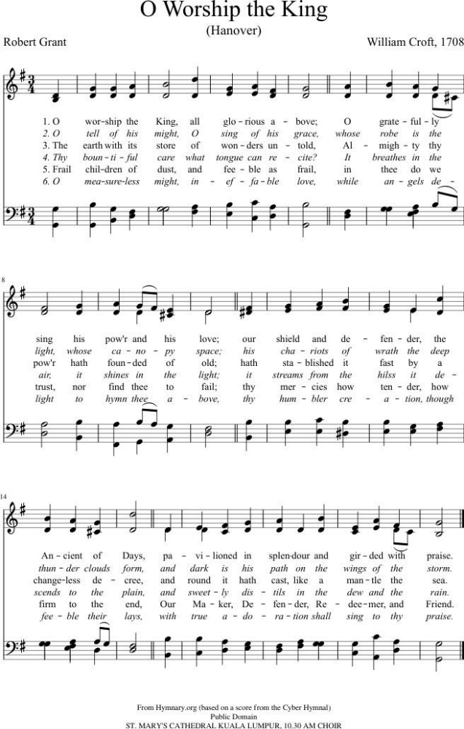
https://www.youtube.com/watch?v=-6tomvcks4s
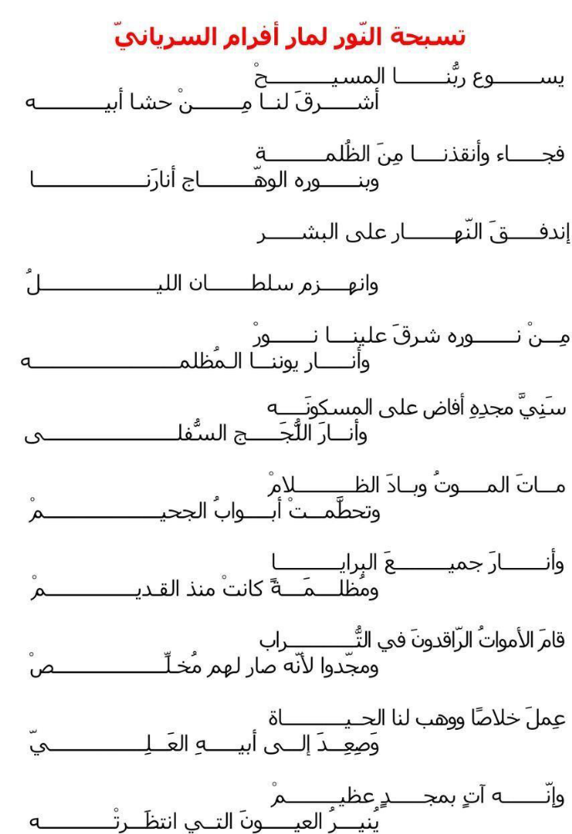

Engelsk oversettelse:
Song of Light (Saint Ephrem)
The Light of the just and joy of the upright is Christ Jesus our Lord.
Begotten of the Father, he manifested himself to us.
He came to rescue us from darkness
and to fill us with the radiance of his light.
Day is dawning upon us; the power of darkness is fading away.
From the true Light there arises for us
the light which illumines our darkened eyes.
His glory shines upon the world
and enlightens the very depths of the abyss.
Death is annihilated, night has vanished, and the gates of Sheol are broken.
Creatures lying in darkness from ancient times are clothed in light.
The dead arise from the dust and sing because they have a Saviour.
He brings salvation and grants us life.
He ascends to his Father on high.
He will return in glorious splendour
and shed his light on those gazing upon him.

Taizé sang

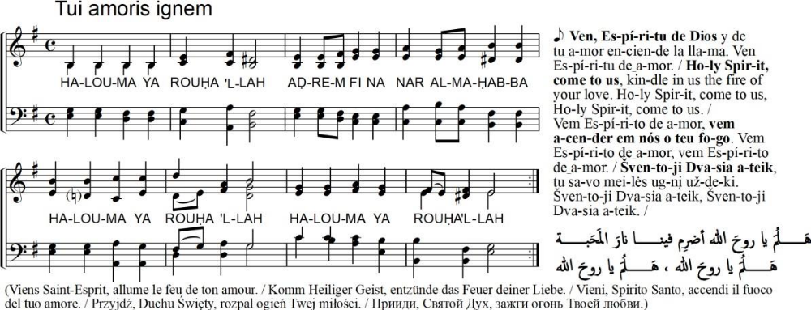

Musikk: Jacques Berthier (1923-1994), copyright © Ateliers et Presses de Taizé, 71250 Taizé, Frankrike.

Trisagion
På Engelsk og Gresk: https://www.youtube.com/watch?v=oJ6of7ViJ5w
På Syrisk: https://www.youtube.com/watch?v=FLBEzlUt2EA
På Armensk: https://youtu.be/gPM-BKYVpNE

Syrisk salme
https://www.youtube.com/watch?v=nno6k0i8zd4

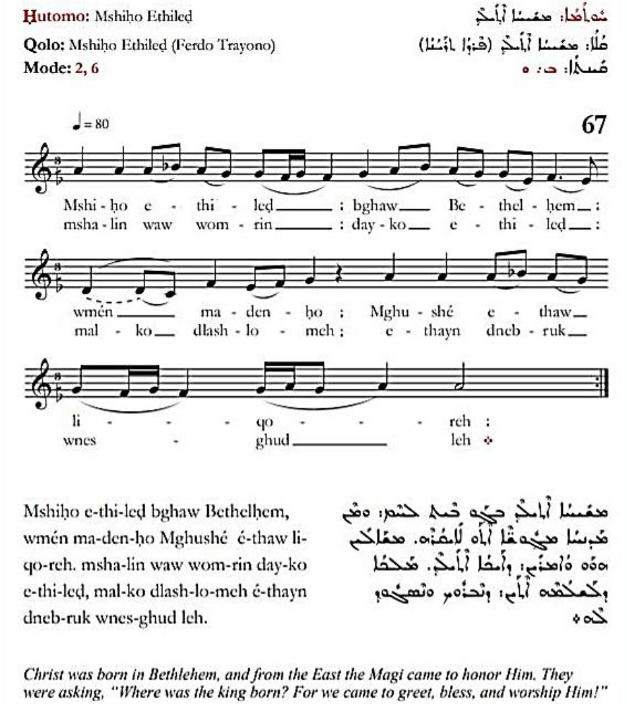

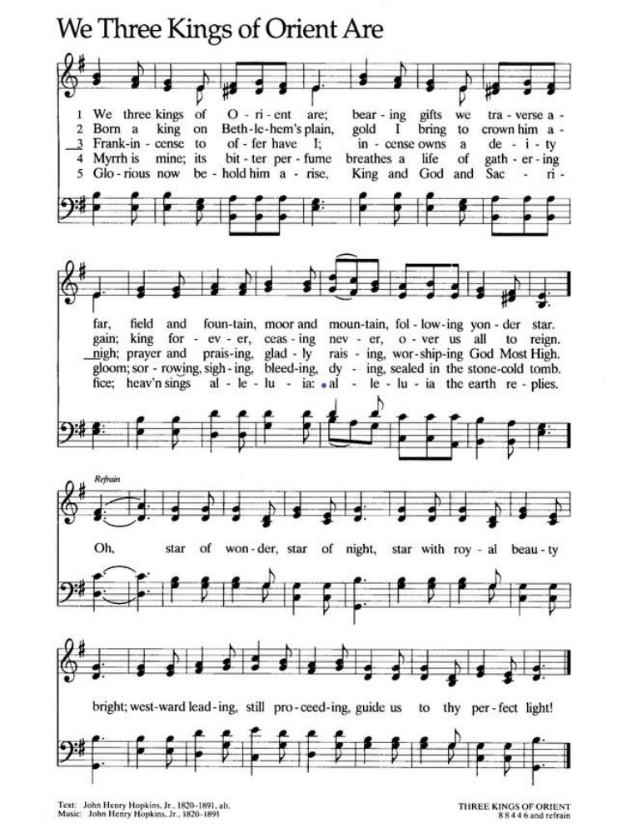

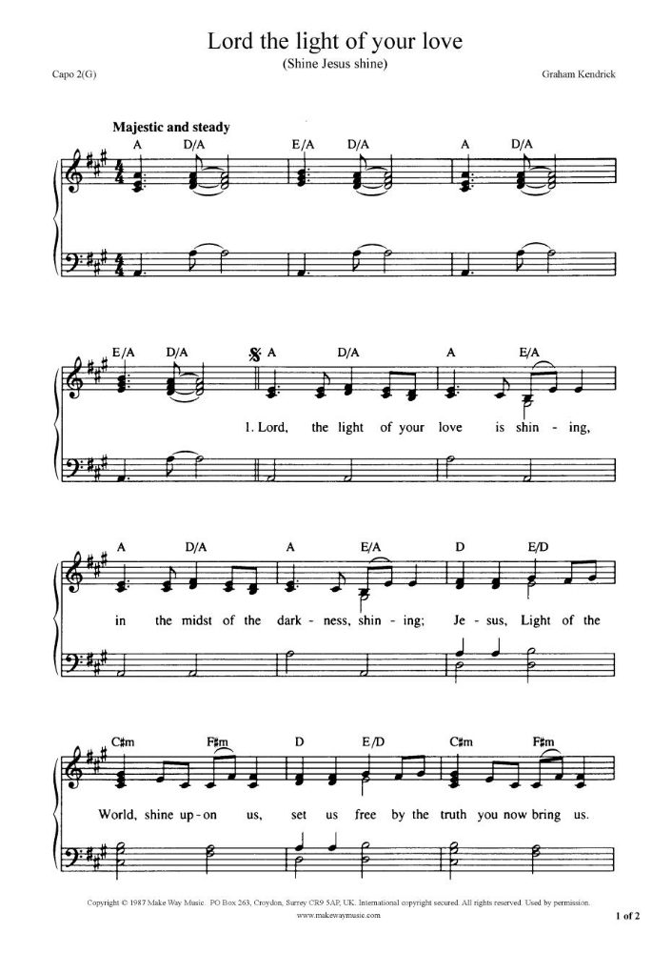

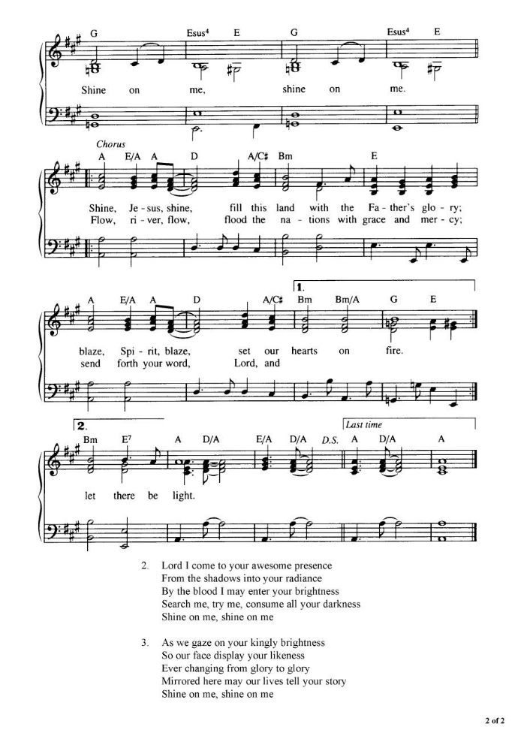

Koptisk salme
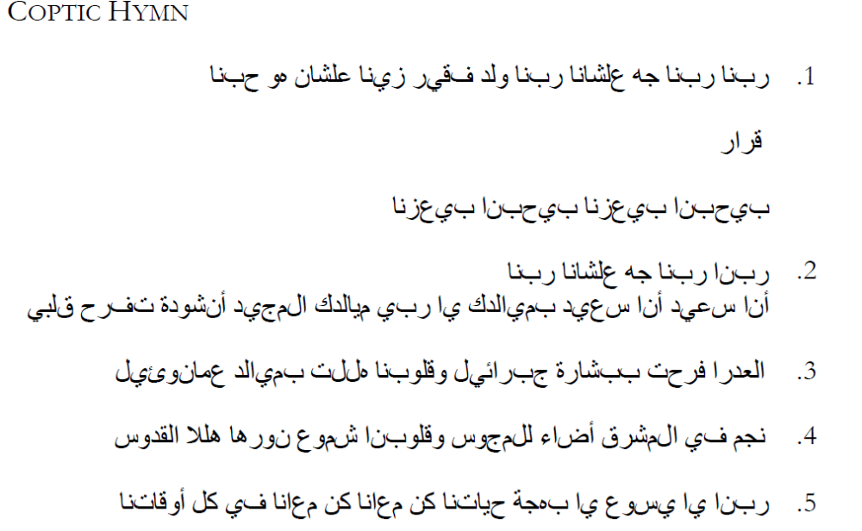

Our Lord, our Lord
Our Lord, our Lord, came for us our Lord. Born in the manger like us
because He truly loves us.
Refrain: He loves all of us; He redeemed all of our souls. (2)
Our Lord, our Lord, came for us our Lord. (2) I am glad, I am glad; by your birth, O my Lord, your birth in Bethlehem a great joy to my soul.
Our Lord, our Lord, came for us our Lord. (2) The virgin rejoiced in the word of Gabriel,
our hearts are happy in the birth of Emmanuel.
Our Lord, our Lord, came for us our Lord. (2) In the east was a star shone to the wise men. Our hearts are candles lit to the Holy Lord.
Our Lord, our Lord, came for us our Lord. (2) The angels in the sky praised the Lord
for His birth. Glory to God in the highest and peace be on earth.
Our Lord, our Lord, came for us our Lord (2)
https://www.youtube.com/watch?v=93_cM9FwSe8&feature=youtu.be&fbclid=IwAR1YUA_ a0yTKpJ7WQCnjogpvNgXAwkO4E-M5dWXnoovWwHbNiESCwJgYZN8

Disse salmene er foreslått av Kirkerådet i Midtøsten, som forberedte det første prosjektet til Bønneuken for kristen enhet 2022, og er publisert under dets ansvar.

